TryHackMe Beginner Labs Progress Summary

Name: Pratham Kawade (248426)-B

Internship Program: Digisuraksha Parhari Foundation

Powered by: Infinisec Technologies Pvt. Ltd.

Hello World Room Overview

Room Link: <https://tryhackme.com/room/hello>

Goal of the Room:

Hello World Room Overview

Resources & Commands Utilized:

* TryHackMe web interface
* VPN (OpenVPN)
* Basic terminal commands (if applicable)

Knowledge Gained: Hello World Room Overview Process & Approach: Hello World Room Overview Personal Reflections:

Hello World Room Overview

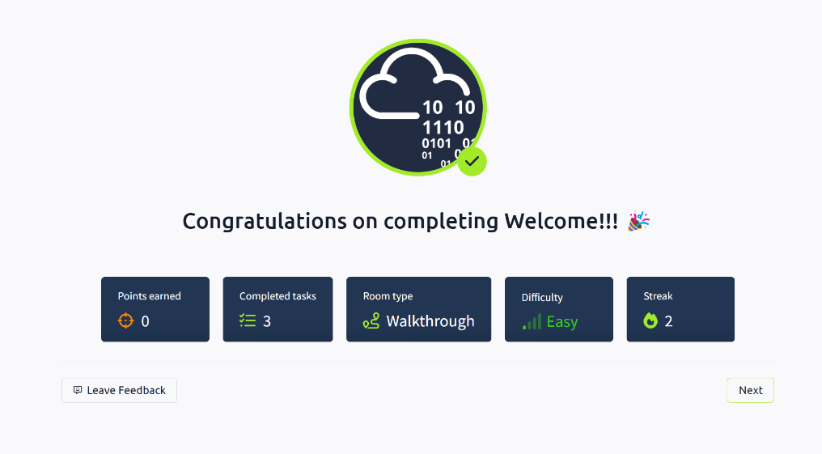

Getting Familiar with TryHackMe

Room Link: <https://tryhackme.com/room/howtousetryhackme>

Goal of the Room:

Getting Familiar with TryHackMe

Resources & Commands Utilized:

* TryHackMe web interface
* VPN (OpenVPN)
* Basic terminal commands (if applicable)

Knowledge Gained: Getting Familiar with TryHackMe Process & Approach: Getting Familiar with TryHackMe Personal Reflections:

Getting Familiar with TryHackMe

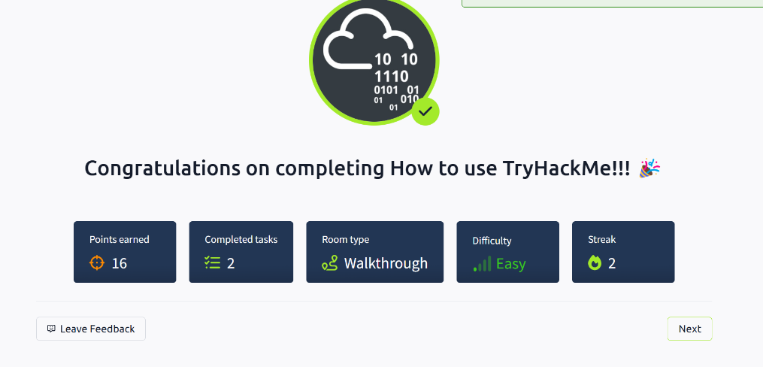

Kickstarting Cybersecurity Learning

Room Link: <https://tryhackme.com/room/gettingstarted>

Goal of the Room:

Kickstarting Cybersecurity Learning

Resources & Commands Utilized:

* TryHackMe web interface
* VPN (OpenVPN)
* Basic terminal commands (if applicable) Knowledge Gained:

Kickstarting Cybersecurity Learning Process & Approach: Kickstarting Cybersecurity Learning Personal Reflections:

Kickstarting Cybersecurity Learning

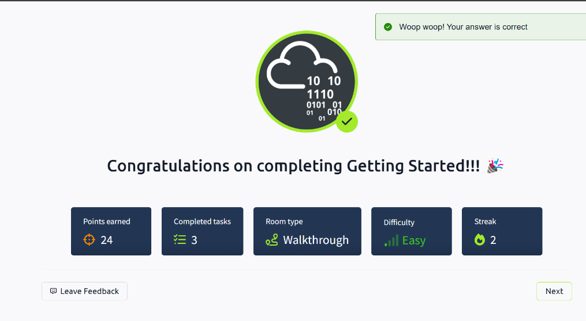

Introduction to the Platform

Room Link: <https://tryhackme.com/room/welcome>

Goal of the Room:

Introduction to the Platform

Resources & Commands Utilized:

* TryHackMe web interface
* VPN (OpenVPN)
* Basic terminal commands (if applicable)

Knowledge Gained: Introduction to the Platform Process & Approach: Introduction to the Platform Personal Reflections:

Introduction to the Platform

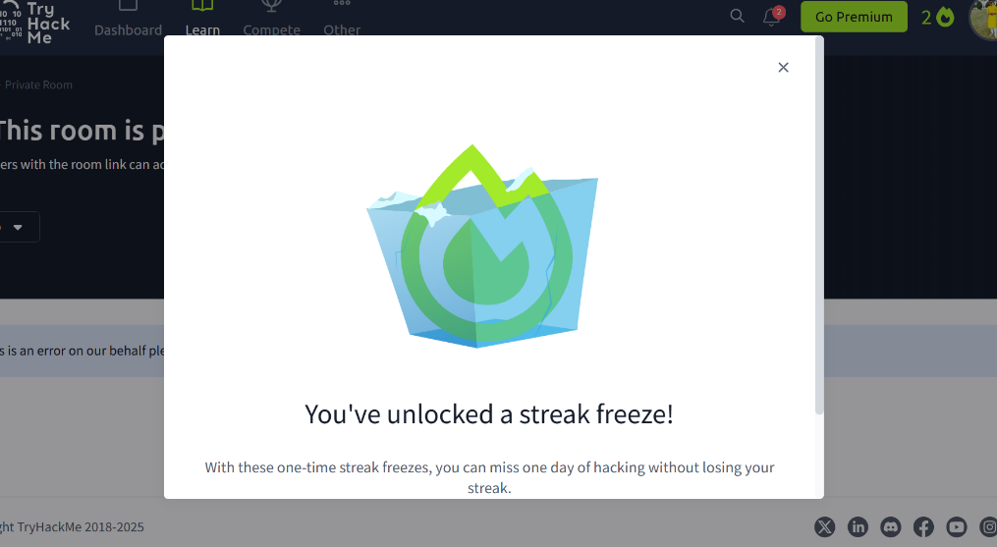

Interactive TryHackMe Tutorial Room Link: <https://tryhackme.com/room/tutorial>

Goal of the Room:

Interactive TryHackMe Tutorial

Resources & Commands Utilized:

* TryHackMe web interface
* VPN (OpenVPN)
* Basic terminal commands (if applicable)

Knowledge Gained: Interactive TryHackMe Tutorial Process & Approach: Interactive TryHackMe Tutorial Personal Reflections:

Interactive TryHackMe Tutorial

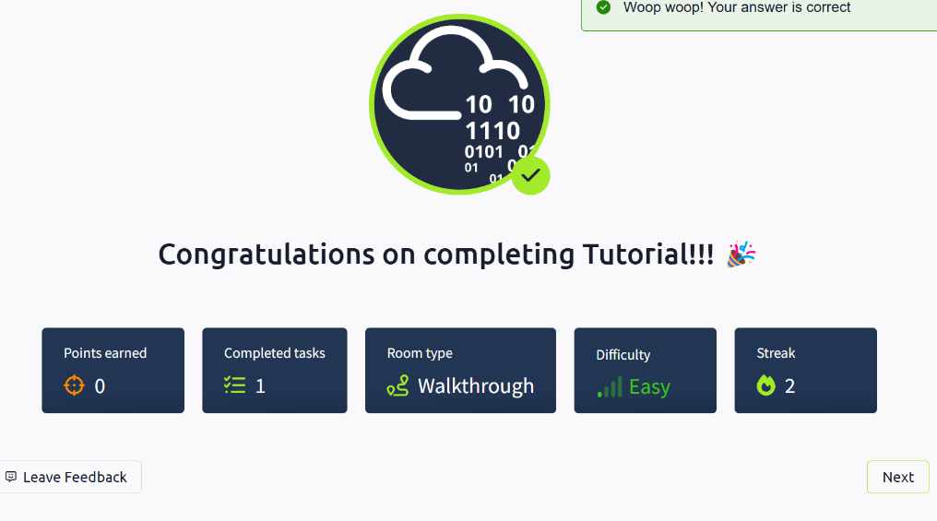

VPN Setup and OpenVPN Configuration Link: <https://tryhackme.com/room/openvpn>

Goal of the Room:

VPN Setup and OpenVPN Configuration

Resources & Commands Utilized:

* TryHackMe web interface
* VPN (OpenVPN)
* Basic terminal commands (if applicable) Knowledge Gained:

VPN Setup and OpenVPN Configuration Process & Approach:

VPN Setup and OpenVPN Configuration Personal Reflections:

VPN Setup and OpenVPN Configuration

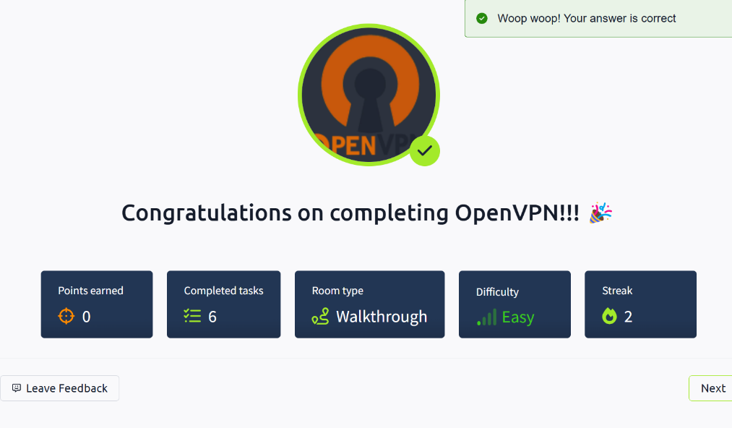

Introduction to the Beginner Path

Room Link: <https://tryhackme.com/room/beginnerpathintro>

Goal of the Room:

Introduction to the Beginner Path

Resources & Commands Utilized:

* TryHackMe web interface
* VPN (OpenVPN)
* Basic terminal commands (if applicable)

Knowledge Gained: Introduction to the Beginner Path Process & Approach:

Introduction to the Beginner Path

Personal Reflections:

Introduction to the Beginner Path

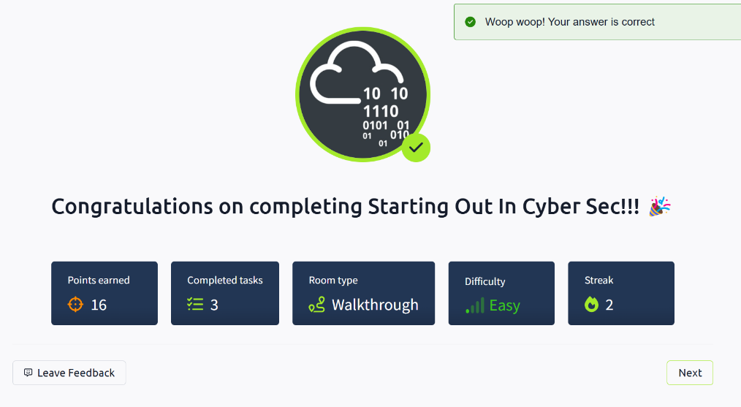

Starting Your Journey in Cybersecurity

Room Link: <https://tryhackme.com/room/startingoutincybersec>

Goal of the Room:

Starting Your Journey in Cybersecurity

Resources & Commands Utilized:

* TryHackMe web interface
* VPN (OpenVPN)
* Basic terminal commands (if applicable) Knowledge Gained:

Starting Your Journey in Cybersecurity Process & Approach:

Starting Your Journey in Cybersecurity Personal Reflections:

Starting Your Journey in Cybersecurity

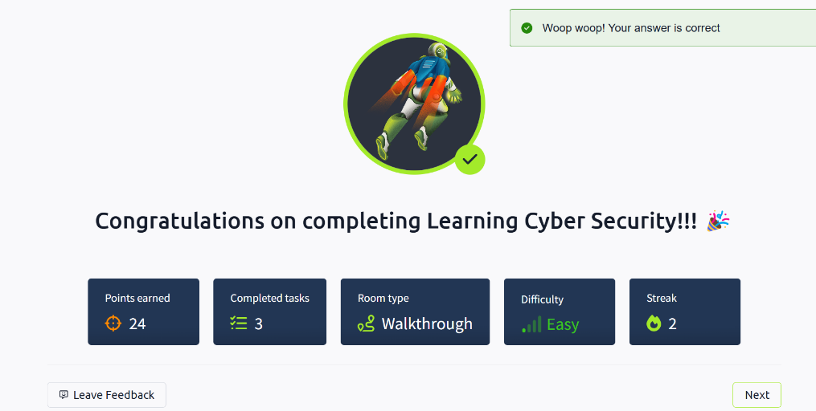

Basics of Cybersecurity Research

Room Link: <https://tryhackme.com/room/introtoresearch>

Goal of the Room:

Basics of Cybersecurity Research

Resources & Commands Utilized:

* TryHackMe web interface
* VPN (OpenVPN)
* Basic terminal commands (if applicable)

Knowledge Gained:

Basics of Cybersecurity Research Process & Approach: Basics of Cybersecurity Research Personal Reflections:

Basics of Cybersecurity Research

